Project Design Phase
Solution Architecture

Date | 28 August 2026
Project Name | Employee Raise Issue
Maximum Marks | 4 Marks

Solution Architecture:
Solution architecture for the Employee Raise Issue project is a structured process that connects the organization’s workplace issue-management needs with an appropriate software solution. Its goals are to:
● Find the best technology solution to provide a centralized platform for employees to raise, track, and resolve workplace issues.
● Describe the structure, components, behavior, and interactions of the Employee Raise Issue system for employees, HR/Admin, and concerned departments.
● Define the features, development phases, and system requirements needed for issue submission, assignment, tracking, resolution, notifications, and reporting.
● Provide clear technical specifications for designing, developing, managing, and delivering the Employee Raise Issue system efficiently and securely.

Example - Solution Architecture Diagram:

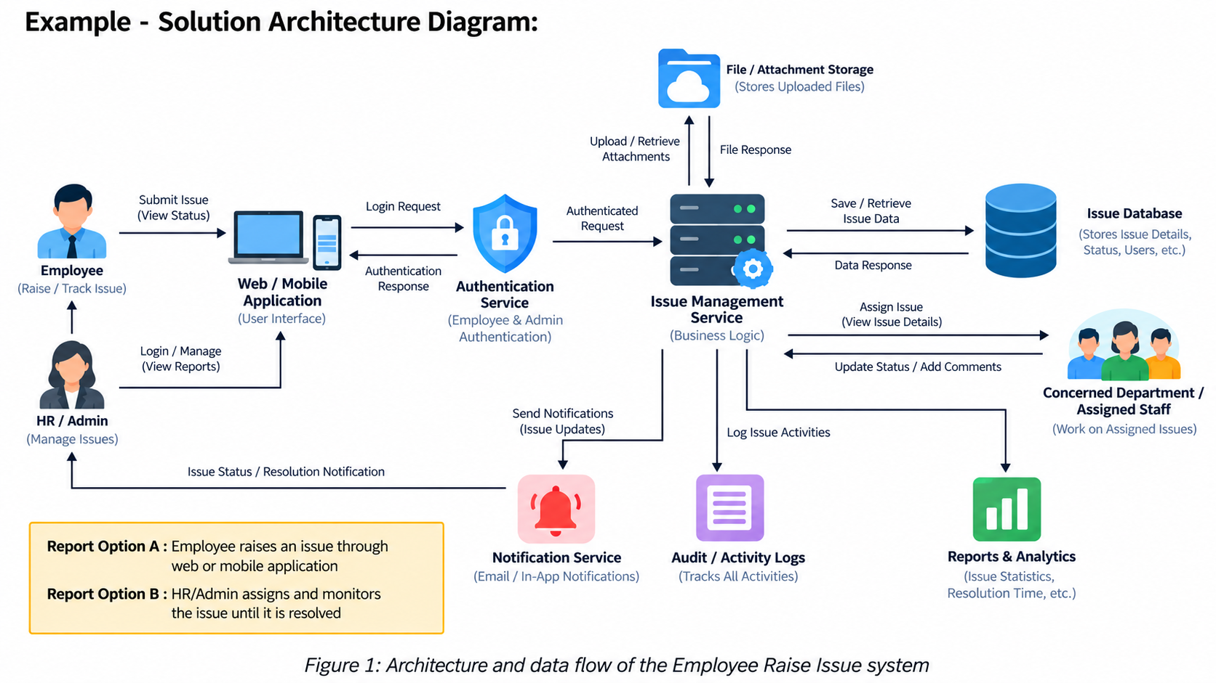

Reference:
https://aws.amazon.com/architecture/?utm_source=chatgpt.com

